CS 110 Final Project
The Game of Kings
BY: Brian Doyle and Leandro Ribiero
Section B-54

Welcome to the Game of Kings! This is a very simple drinking game, simulated through our GUI program. Everyone enjoys drinking so let's play! There will be digital card deck placed on the GUI, so the users will be able to see what card they draw. Along with the card, the rule associated with this card will also be displayed, so anyone can play without knowing how. After entering the number of people playing the game will start, and will not end until the card deck has been exhausted. Enjoy!

- Starting the game – The Opening Screen
The player will first have to enter the number of people who will be participating in the game. Once this has been done the game can officially start. Player 1 will be the one who first selects a card.
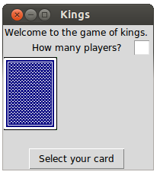
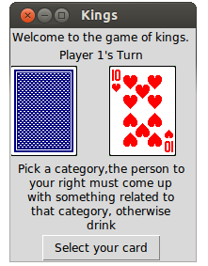

- Playing through – The Bulk of the Deck
The players of the game will rotate through until all 52 cards have been drawn. However if a king is drawn from the deck the player will be able to create a rule which will be displayed throughout the game until its finish.
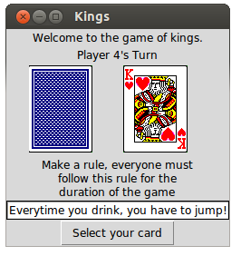
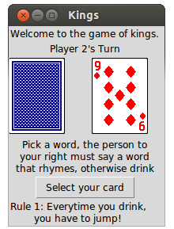

- Finishing the Game – The Finish
Once all the cards have been played the game will come to an end. The GUI will display a final screen with a finishing quote and a “Quit” button. Hope you enjoyed playing!
